Project Step 2 Draft

Group 46: Joshua Cicchinelli, Mauricio Marin Gutierrez, and Son Thai Do Nguyen

a) Fixes based on Feedback from Step 1
Skyla Chen:
Hello Team 46!
- Your review should provide helpful and insightful answers to the following questions:
  - Does the overview describe what problem is to be solved by a website with DB back end? If yes, summarize. If not, what changes would better support describing the problem to be solved?
    - I think your guy’s overview does a great job at explaining how your database will manage inventory for a library. I think that you can implement a bit more strength in by mentioning more specific ideas like tracking books that are overdue or what to do with misplaced items, etc.
  - Does the overview list specific facts? If yes, summarize what the facts illustrate about the proposed DB solution. If not, what facts would better support illustrating the scope and scale of the proposed DB solution?
    - Yeah, I think the over does lists pretty specific facts like the numbers provided as this helps show that this is indeed a mid-scale library database.
  - Are at least four entities described, and does each one represent a single idea to be stored as a list? If yes, summarize. If not, based on the course material, what changes can you suggest to improve?
    - Yes, at least four entities are described, each doing a great job representing a clear concept.
  - Does the outline of entity details describe the purpose of each, list attribute datatypes and constraints, and describe relationships between entities? If yes, summarize. If not, based on the course material, what changes can you suggest to improve?
    - Yes, the outline of entity details describe the purpose with the appropriate and specific datatypes
  - Are 1:M relationships correctly formulated? Is there at least one M:M relationship? Does the ERD present a logical view of the database? If yes, summarize. If not, based on the course material, what changes can you suggest to improve?
    - Yes the ERD shows the 1:M relations.
      - Book → BookCopies
      - Patrons → Loans
      - BookCopies → Loans
    - As well as M:M relations:
      - Books <-> Authors
      - Books <->Genres
  - Is there consistency in a) naming between overview and entity/attributes b) entities plural, attributes singular c) use of capitalization for naming? If yes, summarize. If not, based on the course material, what changes can you suggest to improve?
    - Looking it over, I’d say there is a bit of inconsistency in capitalization, where the names in the ERD are shown in plain text rather than camelCase. But an easy fix.
All is original, besides the questions which were provided in the review assignment.

Sammy Alyooi16h:
Group 46 overview describes the problem set and shows that it can be solved by a web application with a database backend. I think the library system involves many entities with attributes of different data types and domains. The overview discusses storing, retrieving, altering, and presenting data, all of which I believe can be implemented using a model-view-controller or MVC concept website and database with CRUD operations and API endpoints to perform various operations. The overview of the library system specifies some of the main facts and transactions like number of books, registered members, central database, and record keeping.
There are six entities, with master entities such as Books, Patrons, and Authors. Some entities have primary keys and 1:M relationships, with their PK being referenced in other entities as FK, as described in Chapters 11 and 16 of the textbook.
Each entity has a short description that highlights its purpose. For example, the Patrons entity records members or customers of the library who can borrow materials. Loans, on the other hand, tracks book checkout transactions by patrons and records fees, book status, and transaction dates. The entities’ 1:M relationships are described with good clarity. Patrons has a 1:M relationship with Loans, implemented with PatronID being referenced as FK inside Loans. Also, BookCopies has a 1:M relationship with Loans, where the BookCopies attribute CopyID is used as FK inside Loans. I think this relationship needs a bit more explanation to highlight whether it takes place over a period of time or represents a single transaction.
There is a good level of consistency between the project overview and the entities and attributes. One thing that stood out was that I only saw references to physical book copies, but no mention of digital copies, magazines, or other library materials.
All my work is original.

Santos Garcia Santiago:
Hello everyone,
The drafts looks great and after reviewing here is some of my comments and feedback of the draft:
This overview describes efficiently that the library will keep inventory of its maximum 43,000 books and it will be able to serve to a maximum of 25,000 members with a website and database and this way library does not rely on manual tools for this task, thus making the use of the library easier and quicker for clients and employees.
Overall, the outline of entities and each of their attributes describes their relationships, the datatypes and their constraints accurately and have consistency across each of them. One update I would make is to the ER Diagram to include the list of attributes in each table and the relationship between those attributes as Primary and Foreign Keys. As well as adding the intersection tables for BookAuthors and BookGenres for the Many-to-Many relationships. Other than that the draft is following the metrics for the project.
The review and all the feedback was completed and original from myself.
Good Luck on the Term,
Santos
Lindsey Clement:
I like how you separated book titles from physical copies and tracked loans at the copy level. Nice work!

- Jonathan Salfen:
- Does the overview describe what problem is to be solved by a website with DB back end? If yes, summarize. If not, what changes would better support describing the problem to be solved?
  - The database will manage a book inventory for a medium size library.
- Does the overview list specific facts? If yes, summarize what the facts illustrate about the proposed DB solution. If not, what facts would better support illustrating the scope and scale of the proposed DB solution?
  - Manages up to 43,000 books.
  - Will serve 15-25k registered members.
  - Software will be used by support staff and clients.
  - Access allowed to the software 24/7.
- Are at least four entities described, and does each one represent a single idea to be stored as a list? If yes, summarize. If not, based on the course material, what changes can you suggest to improve?
  - Books - Records the details of books in the library
  - Patrons - Records library members who can borrow materials.
  - Loans - Tracks all book checkout transactions between patrons and book copies,
  - recording dates, fees and status
  - Authors - Stores information about authors of the book(s)
  - Genres - Stores a list of genres that can be associated with books
  - BookCopies - Track the physical copy of a book (Some book titles can have multiple
  - copies)
- Does the outline of entity details describe the purpose of each, list attribute datatypes and constraints, and describe relationships between entities? If yes, summarize. If not, based on the course material, what changes can you suggest to improve?
  - Yes mostly, however there are a couple things to note:
    - Books table - How are books with same title/publication year/publisher to be handled with regards to varying ISBNs? (i.e. paperback vs hardcover have different ISBNs). It might be useful to have an additional field in Books that describes that difference (hardcover, paperback, special edition, etc.)
- Are 1:M relationships correctly formulated? Is there at least one M:M relationship? Does the ERD present a logical view of the database? If yes, summarize. If not, based on the course material, what changes can you suggest to improve?
  - 1:M relationships are correctly implemented via foreign keys:
    - Books → BookCopies
    - Patrons → Loans
    - BookCopies → Loans
  - M:N relationships are appropriately resolved using intersection tables:
    - Books ↔ Authors via BookAuthors
    - Books ↔ Genres via BookGenres
  - Improvement suggestions for the ERD:
    - Show participation (optional or mandatory).
    - Including fields listed under each table would make the diagram more usable.
    - Show intersection tables BookAuthors and BookGenres.
- Is there consistency in a) naming between overview and entity/attributes b) entities plural, attributes singular c) use of capitalization for naming? If yes, summarize. If not, based on the course material, what changes can you suggest to improve?
  - Naming looks consistent and appropriate.
  - Improvement Suggestion:
    - The name BookCopies is confusing and doesn’t immediately describe the table use case (it makes me think the Books table is tracking the main book, and the BooksCopies is tracking photocopied copies). Consider something more specific, like BookPhysicalCopies, PhysicalBooks, or rename both Books and BooksCopies to: Titles or Works and Items or PhysicalItems (separating the concepts of abstract intellectual work and tangible inventory).
- Prompt used to review last 3 questions from the writing prompt for the assignment [from https://canvas.oregonstate.edu/courses/2031764/assignments/10323333?module_item_id=26243383]. AI responses were integrated with reviewer thoughts.
  - Prompt: “look over the attachment, and help fill out the following questions from the perspective of a database professor [3 questions inserted here]. [PDF of draft from Group 46 attached]”
  - Date: 1/19/26
  - AI Source URL: https://chatgpt.com/
- Prompt used to formulate improvement suggestion for last question from the writing prompt from https://canvas.oregonstate.edu/courses/2031764/assignments/10323333?module_item_id=26243383. AI responses were integrated with reviewer thoughts.
  - Prompt: “how could you separate the ideas of physical books in the library and the electronic classification of them? I'm trying to find better names for books and BooksCopies”
  - Date: 1/19/26
  - AI Source URL: https://chatgpt.com/

Actions based on the feedback:
- Updated capitalization so that terms were consistent throughout due to Skyla’s and Jonathan’s suggestion.
- Followed Sammies tip to allow for other types of books.
- Fleshed out the relationship between BookCopies and Loans according to Sammy’s suggestion.
- Used Santos’s suggestion to make the ERD better.
Upgrades to the Draft version:
- Added an attribute in table Books to allow for the medium with which the book is (digital, physical, etc.); “bookMedia: VARCHAR (50), not NULL”.
- Added “Each row is a separate transaction showing what happens over time.” to clarify the Loan to BookCopy relationship.
- Included the list of attributes in each table and the relationship of the Keys.
- Consider the relationship of ENUM vs VARCHAR for some attributes
- Updated phone to have 10 characters to maintain consistency.

b) Project Overview and Database Outline - Updated Version:
Overview:
This library database will keep an inventory of all the books that a medium size library holds, up to 43,000 books. It will be able to serve 15,000-25,000 registered members,with a centralized database. Furthermore, this system will store data on each of the books as well as facilitate a record of transactions that patrons will be able to perform when they borrow books. Clients will be able to use this software at the same time; 24/7. Without this, the library would have to rely on fragmented or manual tools.

Database Outline:
- Books: Records the details of books in the library
  - bookID: INT, auto_increment, unique, not NULL, PK
  - ISBN: VARCHAR(13), not NULL, UQ
  - title: VARCHAR(255), not NULL
  - publicationYear: YEAR
  - publisher: VARCHAR(100)
  - bookMedia: VARCHAR (50), not NULL

  - Relationships:
    - A M:N relationship between Books and Authors is implemented using BookAuthors intersection table.
    - A M:N relationship between Books and Genres is implemented using the BookGenres intersection table.
    - A 1:M relationship between Books and BookCopies is implemented with bookID as a FK inside of BookCopies

- Patrons: Records library members who can borrow materials.
  - patronID: INT, auto_increment, unique, not NULL, PK
  - libraryCardNumber: VARCHAR(20), not NULL, UQ
  - firstName: VARCHAR (50), not NULL
  - lastName: VARCHAR (50), not NULL
  - email: VARCHAR (100), not NULL, UQ
  - phone: VARCHAR (10)

  - Relationship:
    - A 1:M relationship between Patrons and Loans is implemented with patronID as a FK inside of Loans.

- Loans: Tracks all book checkout transactions between patrons and book copies, recording dates, fees and status. Each row is a separate transaction showing what happens over time.
  - loanID: INT, auto_increment, unique, not NULL, PK
  - copyID: INT, not NULL, FK
  - patronID: INT, not NULL, FK
  - checkoutDate: DATE, not NULL, default (CURRENT_DATE)
  - dueDate: DATE, not NULL
  - returnDate: DATE, NULL
  - lateFee: DECIMAL (5,2), default 0.00
  - status: ENUM (‘Active’, ‘Returned’, ‘Overdue’, ‘Lost’), default ‘Active’

  - Relationships:
    - A 1:M relationship between Patrons and Loans is implemented with patronID as a FK inside of Loans.
    - A 1:M relationship between BookCopies and Loans is implemented with copyID as FK inside of Loans.

- Authors: Stores information about authors of the book(s)
  - authorID: INT, auto_increment, unique, not NULL, PK
  - firstName: VARCHAR(50), not NULL
  - lastName: VARCHAR(50), not NULL
  - birthYear: SMALLINT, NULL

  - Relationship(s):
    - A M:N relationship between Books and Authors is implemented using the BookAuthors intersection table.

- Genres: Stores a list of genres that can be associated with books
  - genreID: INT, auto_increment, unique, not NULL, PK
  - genreName: VARCHAR(50), unique, not NULL

  - Relationship(s):
    - A M:N relationship between Books and Genres is implemented using the BookGenres intersection table.

- BookCopies: Track the physical copy of a book (Some book titles can have multiple copies)
  - copyID: INT, auto_increment, unique, not NULL, PK
  - bookID: INT, not NULL, FK
  - acquisitionDate: DATE, not NULL
  - condition: VARCHAR(20), not NULL
  - location: VARCHAR(50), not NULL
  - status: VARCHAR(20), not NULL

  - Relationship(s):
    - A 1:M relationship between Books and BookCopies is implemented with book ID as a FK inside of BookCopies

- BookAuthors: A join table to associate books and authors
  - bookID: INT not NULL, PK, FK
  - authorID: INT not NULL, PK, FK

  - Relationship(s): A M:N relationship between Books and Authors, where a book may have multiple authors and an author may have written multiple books.

- BookGenres: A join table to associate genres and books
  - bookID: INT not NULL, PK, FK
  - genreID: INT not NULL, PK, FK

  - Relationship(s): A M:N relationship between Books and Genres, where a book may have multiple genres and a genre may have multiple books as part of it.

c) Entity-Relationship Diagram:
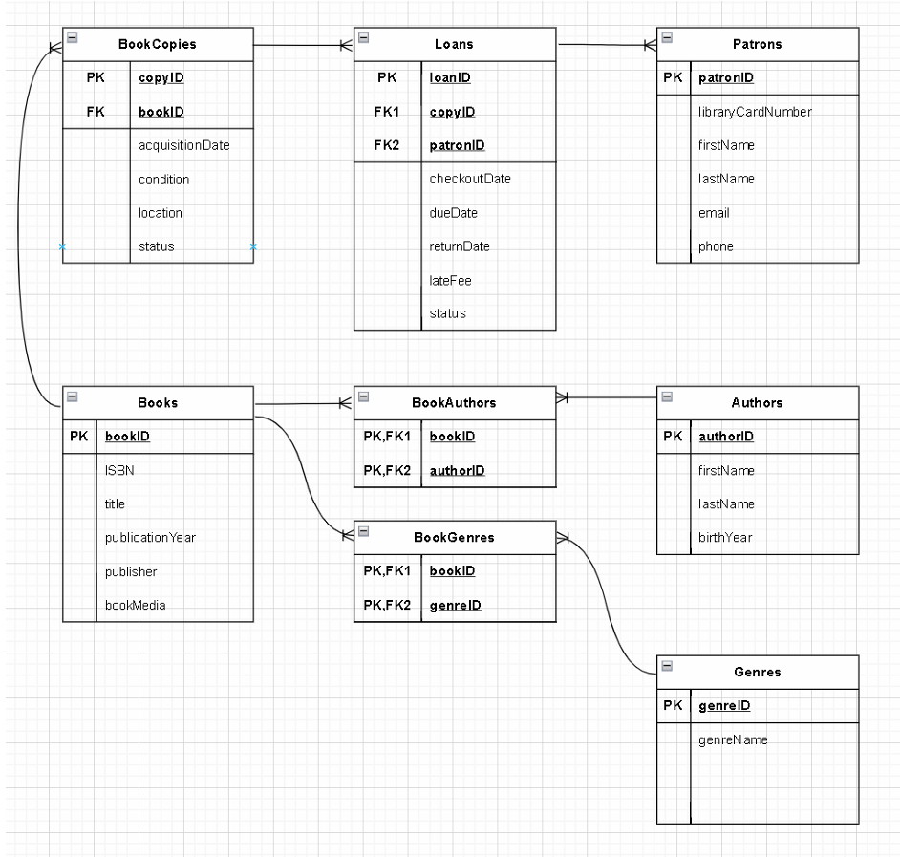

d) Schema Diagram:
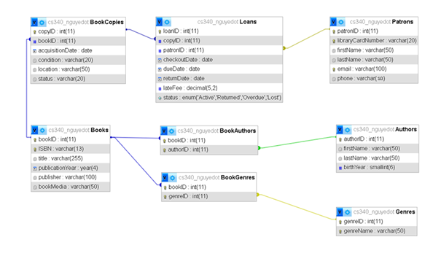

e) Example Data:
Books:
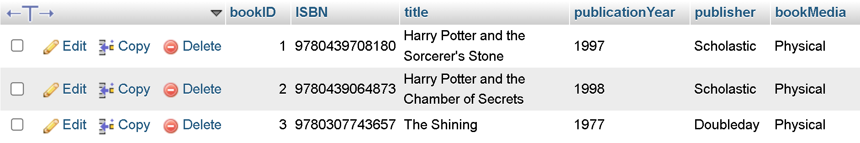
Patrons:
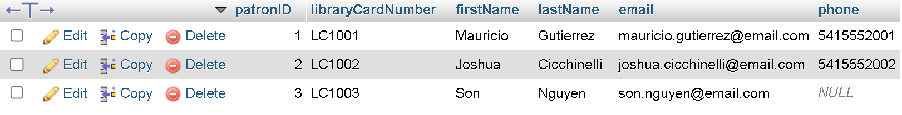
Authors:
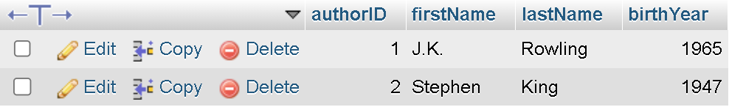
Genres:
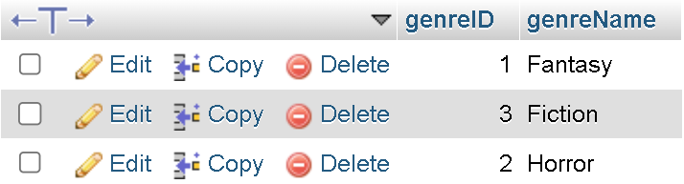
BookCopies:
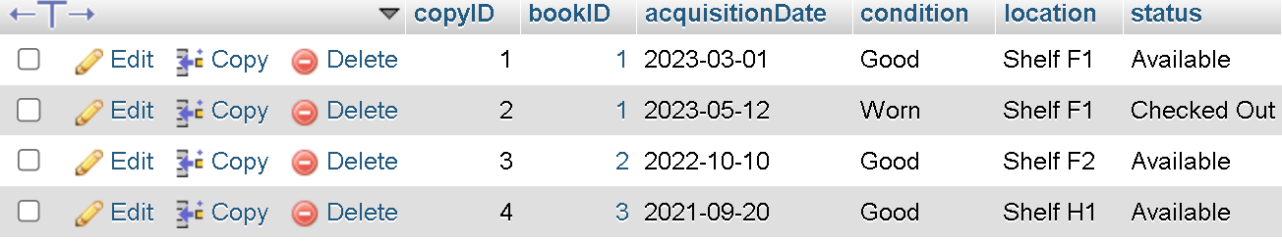
BookAuthors:
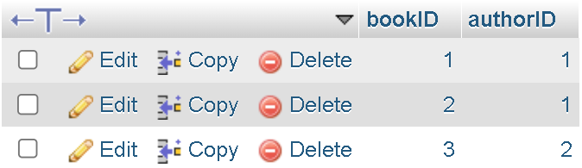
BookGenres:
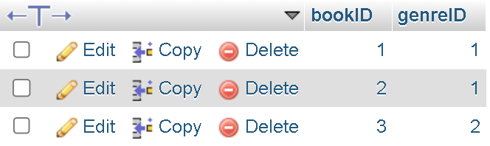
Loans:
